### Business Process Name: Cancel Flight.

Steps:

|  |  |  |  |  |
| --- | --- | --- | --- | --- |
| **Step Name** | **Description** | **Expected Result** | **Screen Name** | **Transaction Name** |
| Step 1 | Invoke the browser and navigate to http://127.0.0.1:1080/WebTours/index.htm | The web tour Homepage should appear | Homepage | 01_Homepage |
| Step 2 | Enter the username and password and click login | Welcome page should appears | Welcome Page | 02_Welcome Page |
|  | Insert Checkpoint to make sure customer profile title appears |  |  |  |
|  | Insert parameter with unique and each iteration, continue in cyclic manner selection |  |  |  |
|  | Correlate the dynamic value such as session id |  |  |  |
| Step 3 | Click on Itinerary tab | Itinerary screen appears | Itinerary Screen | 03_ClickItinerary |
|  | Insert Checkpoint to make sure Itinerary is appeared. |  |  |  |
| Step 4 | Select the Flight which you want to cancel | Cancel screen will appears | Main Screen | 04_Cancel_Click |
| Step 6 | Click Signoff | Home page should appears |  |  |

**You need to correlate the flight ID, I would you to verify in HTTP response to make sure valid LB and RB.**

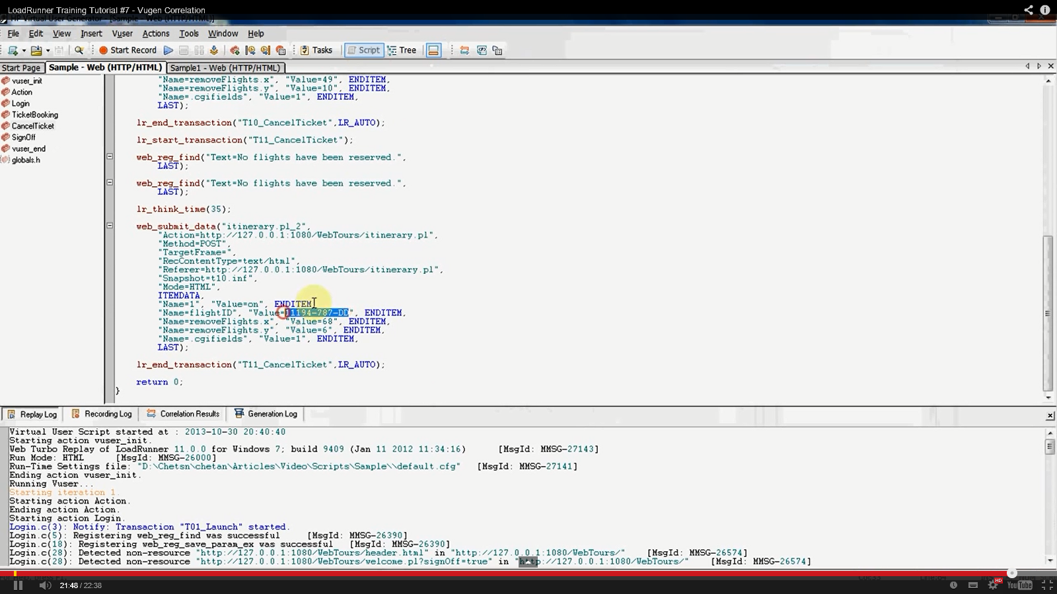

**Sample code where you to correlate.**